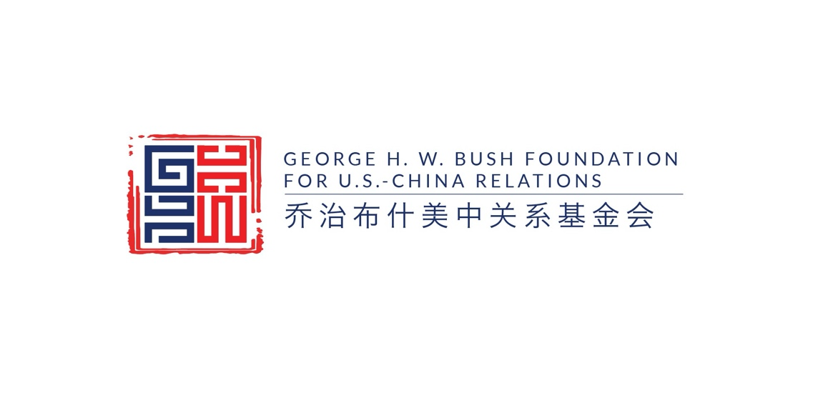

Zoe Leung, Senior Director of Research

Zoe Leung is the senior director of research, working with a wide range of stakeholders and influencers to advance understanding of some of the most salient issues in U.S.-China relations. She is based in New York, New York. She also serves on the Board of Trustees at the United States National Committee of International Council on Monuments and Sites (US/ICOMOS), focusing on bringing intergenerational collaboration to the forefront of World Heritage programs.

Prior to joining the Bush China Foundation, Ms. Leung served as director of the EastWest Institute’s East Asia Program and led the U.S.-China and U.S.-Japan high-level political and military dialogues on Indo-Pacific security issues. Previously, she worked
with United Nations Educational, Scientific and Cultural Organization (UNESCO) in the United States and China with a specialization in World Heritage programs. She holds a master’s degree in international policy analysis from the Elliott School of International Affairs of the George Washington University and a bachelor’s degree in historic preservation from the Savannah College of Art and Design, where she graduated as a Presidential Medalist.

Ms. Leung is a regular contributor to several magazines and newspapers on Asia-Pacific security issues including Foreign Policy, the National Interest, the South China Morning Post, the Hill and the Diplomat. In addition to U.S.-China relations and Asia-Pacific security issues, her interests include South Asian affairs and the role of cultural heritage in peacebuilding. A native of Hong Kong, Ms. Leung has worked in Taipei, Shanghai, Washington, DC and New York.

